Asia-China-Coin-Spade-Flat Handle-H 3.470 R 5

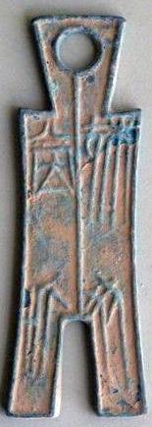 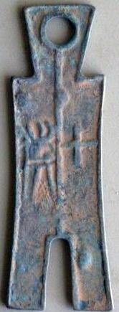

Dang Jin Spade, Flat Handle, , Square Foot (350-250 BCE) H 3.70 obv. Pe3i Bi Dang Jin, Rev. Shi Huo, DCD 285, FD 289.9cm X3cm, 3.54 inch X1.18inch

The weight：40g